CS210 Project Three: “Corner Grocer” Item-Tracking Program

Brandon Lee Villagomez
Southern New Hampshire University
CS 210: Programming Languages
Professor Bary Pollack
February 19, 2025

The Grocery Tracking Program is designed to help Corner Grocer analyze and track the frequency of grocery items from a given input file. The program reads a grocery item data set, processes the frequency of grocery items, and provides users with multiple options to retrieve item counts and visualizations in the form of a list and a histogram. While the program does not yet have the most appealing user interface, it aims to be as user-friendly as possible while retaining functionality and simplicity.
Upon execution, the program will load data from a file, in this case, named “CS210_Project_Three_Input_File.txt,” containing a list of purchased grocery items and storing the frequency of each unique item. Furthermore, the program presents the user with four different options from a menu. The first option searches for an item’s frequency. The second option displays all items and their frequency. The third option displays a histogram representing item frequencies, as denoted by asterisks. Finally, the fourth option exits the program. The program will take the user input, perform the corresponding operation, and display the results. Additionally, the program will save the frequency of grocery items in an output file named “frequency.dat.”
In terms of code design, the program follows an object-oriented approach, implemented with the Tracker class, which encapsulates the grocery tracking logic. The program consists of three files: “main.cpp,” “Tracker.h,” and “Tracker.cpp.” “Main.cpp” handles user interaction and the general program flow. “Tracker.h” is a header file that declares the “Tracker” class and its functions. Finally, “Tracker.cpp” implements the functions for loading data, searching items, printing frequency lists, and saving data.
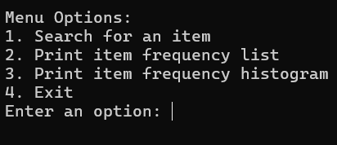
Figure 1: Shows the program's menu, prompting the user to enter a value between 1 to 4, and hit the “Enter” key to execute the desired command.
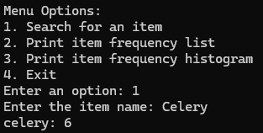
Figure 2: The program has accepted the input of “1”, prompted the user to enter an item name, and outputted the name of the item, followed by the frequency of said item.
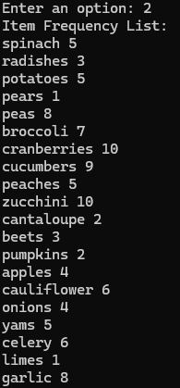
Figure 3: The user has input “2” as a menu choice, and the program has displayed every item on the list by name, followed by a numerical representation of the items as it repeats from the list.
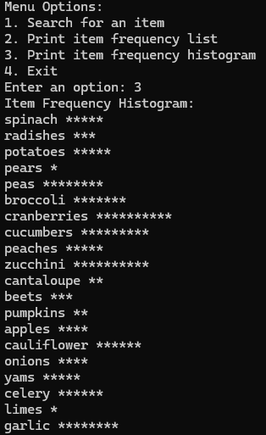
Figure 4: The user has entered “3” as their menu choice, and the program has produced an output that lists every item, followed by a number of asterisks to visually represent the frequency of items.
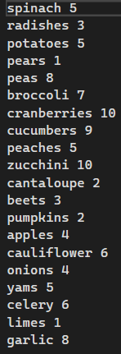
Figure 5: This screenshot contains the plain-text data that was created by the program and named “frequency.dat.”

